Project Technical Proposal

**Team:** music review

**Member:** Zhenhua Qiao

**Intro:**

I am a music lover, so I want to design a music review website. I hope this website can allow users to share their opinions on the albums they preferred, or they disliked. Different people will have different views on the same album. I hope this website can provide people with some fun to share their minds and help them generate new understanding.

**Features:**

1. It will allow users to sign up and sign in.
2. User can create the new reviews.
3. It will allow users to view others’s reviews.

This is a draft design, and it may have some changes, but I will first consider the quality, and then the diversity of functions to provide a good user experience.

My draft design is not good, so I changed it based on the lecture Musicstore-final and other examples of final project.

Diagram:

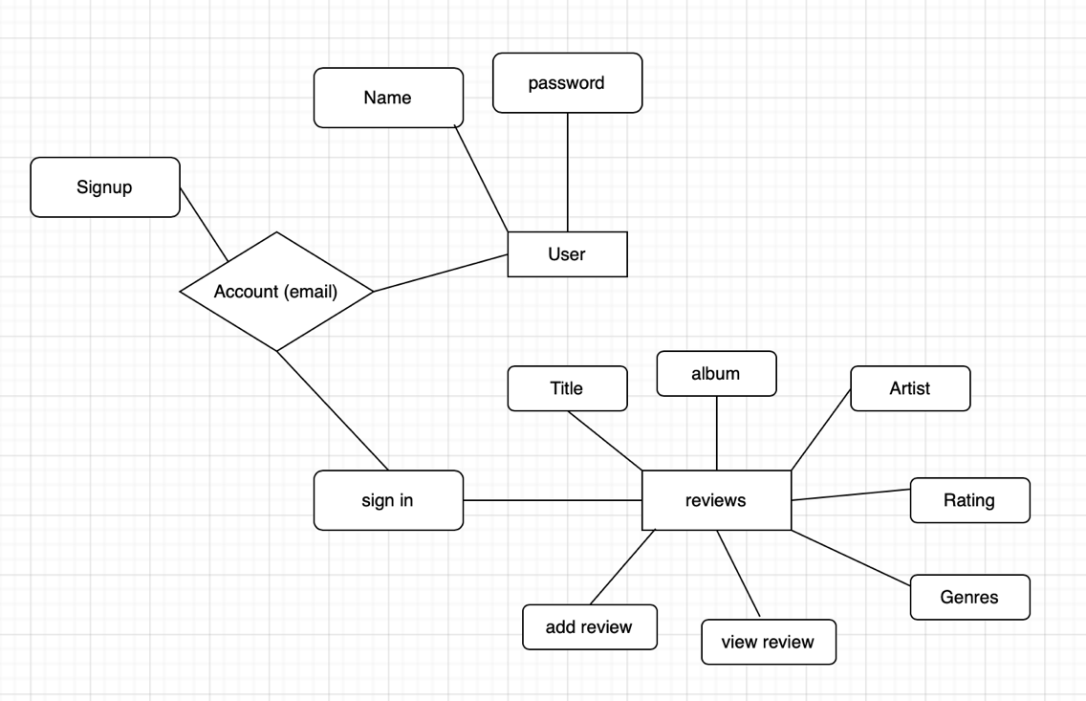

review

|  |  |  |
| --- | --- | --- |
| review_title | varchar | Title of review |
| album_name | varchar | Name of album |
| artist_name | varchar | Name of artist |
| genres | varchar | Genre of album |
| photo_filename | varchar | Name of photo |
| release_date | data | Date of release |
| version_information | decimal | Version |
| review_body | varchar | Review |
| album_rating | varchar | Level of rating |
| number_of_start | decimal | Star rating |

User

|  |  |  |
| --- | --- | --- |
| Name | varchar | Name of user |
| Email | varchar | Account of user |
| password | varchar | Password of account |